**PROJECT DOCUMENTATION**

**Encryption and Decryption of Text By Using Caesar Cipher.**

By

VIGNESH K R 4th year

(B.E Computer Science &Engineering)

MEENAKSHI COLLEGE OF ENGINEERING

|  |  |  |
| --- | --- | --- |
| S. No | CONTENT PRESENCE | PAGE NO. |
| 1 | Abstract | iii |
| 2 | Introduction | 1 |
| 3 | Existing Method | 1 |
| 4 | Proposed method with Architecture | 3 |
| 5 | Methodology | 4 |
| 6 | Implementation | 5 |
| 7 | Conclusion | 7 |

**TABLE OF CONTENT**

**ABSTRACT**

This project delves into the implementation and analysis of the Caesar Cipher, a foundational encryption algorithm, within modern cybersecurity. The objective is to develop a user-friendly software application for encrypting and decrypting messages using the Caesar Cipher. The implementation prioritizes efficient algorithmic execution, input validation, and serves as an educational tool. A thorough security analysis is conducted, considering potential vulnerabilities like brute-force attacks and frequency analysis. The project simulates various threat scenarios to underscore the need for supplementary security measures when employing the Caesar Cipher. Additionally, the project explores potential enhancements to the cipher, aiming to strike a balance between simplicity and security. By offering insights into both theoretical and practical aspects, this project contributes to the understanding of the Caesar Cipher's role in contemporary cybersecurity, highlighting its educational value and limitations in the context of evolving information security.

**INTRODUCTION**

The Caesar Cipher, an elementary yet historically significant encryption technique, serves as the focal point of this project documentation. Dating back to ancient Rome, the Caesar Cipher involves a straightforward substitution method where each letter in the plaintext is shifted a fixed number of positions down or up the alphabet. This project explores the implementation and analysis of the Caesar Cipher within the realm of modern cybersecurity. The objective is to develop a user-friendly software application that enables encryption and decryption using this classical algorithm. Beyond its historical context, the project aims to elucidate the Caesar Cipher's relevance in contemporary information security, emphasizing its educational value. Through a comprehensive examination of both theoretical concepts and practical applications, this documentation seeks to provide a nuanced understanding of the Caesar Cipher's role and limitations in the evolving landscape of cryptography and cybersecurity.

**EXISTING METHOD**

The Caesar Cipher, a basic substitution cipher, primarily employs a single method for encryption and decryption. The method involves shifting each letter of the plaintext by a fixed number of positions in the alphabet. This fixed shift value is known as the key, and it determines the transformation applied to each character. In the standard Caesar Cipher:

1. **Encryption:** Each letter in the plaintext is shifted forward in the alphabet by the key value. For example, with a key of 3, 'A' becomes 'D', 'B' becomes 'E', and so on.

2. **Decryption:** To decrypt the ciphertext, the process is reversed. Each letter in the ciphertext is shifted backward by the key value. Using the same key of 3, 'D' becomes 'A', 'E' becomes 'B', and so forth.

It's worth noting that the Caesar Cipher has a key space of 25 (assuming a standard English alphabet), as a key of 0 or 26 would result in the original message, and a key beyond 26 is equivalent to a smaller key due to the cyclical nature of the alphabet. The simplicity of the Caesar Cipher makes it susceptible to brute-force attacks, and its security is considerably limited compared to more advanced encryption methods used in modern cryptography.

**PROPOSED METHOD WITH ARCHITECTURE**

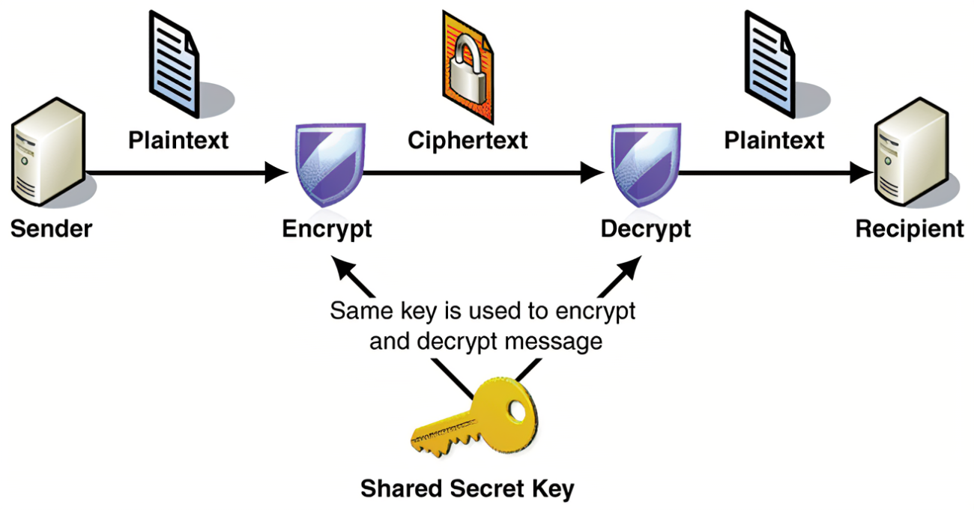

In this architecture of the Caesar Cipher, a classical symmetric-key substitution cipher, is grounded in a simple algorithmic process. It operates on the principle of shifting each character in the plaintext by a fixed number of positions along the alphabet.

During encryption, every letter in the original message undergoes substitution with a character positioned a set distance forward in the alphabet, determined by the chosen key. Conversely, during decryption, this process is reversed, with characters shifted backward by the same key. This uncomplicated architecture is characterized by its ease of implementation, making it historically significant. However, its vulnerability to brute-force attacks is a notable limitation, as the key space is constrained due to the finite number of possible shifts in the alphabet. The Caesar Cipher's architecture exemplifies fundamental principles of substitution ciphers, showcasing both simplicity and susceptibility.

**METHODOLOGY**

The methodology of the Caesar Cipher involves several key points:

1. **Key Selection:** The user chooses a fixed key, which represents the number of positions each letter in the plaintext will be shifted during encryption and decryption.

2. **Alphabetic Substitution:** The core operation is the substitution of each letter in the plaintext with another letter from the alphabet, determined by the fixed key. This creates the ciphertext.

3. **Modular Arithmetic**: The Caesar Cipher employs modular arithmetic to handle shifts beyond the bounds of the alphabet. In a standard English alphabet, modular arithmetic with a modulus of 26 is used to ensure the shifted position wraps around cyclically.

4. **Encryption Process:** During encryption, each letter in the plaintext is shifted forward by the key value. For example, with a key of 3, 'A' becomes 'D', 'B' becomes 'E', and so on.

5. **Decryption Process:** To decrypt, the process is reversed. Each letter in the ciphertext is shifted backward by the key value. Using the same key of 3, 'D' becomes 'A', 'E' becomes 'B', and so forth.

6. **Limited Key Space:** The Caesar Cipher has a limited key space (0 to 25), as using a key beyond this range is equivalent to a smaller key due to the cyclic nature of the alphabet.

7. **Vulnerabilities:** The simplicity of the method makes it susceptible to brute-force attacks, where an attacker systematically tries all possible keys to decrypt the message.

8. **Historical Significance:** Despite its vulnerabilities, the Caesar Cipher holds historical significance as one of the earliest known encryption techniques, commonly used by Julius Caesar for military communication.

**IMPLEMENTATION**

Implementing the Caesar Cipher involves creating algorithms for both encryption and decryption

SOFTWARE REQUIREMENT:

* SOFTWARE: Apache NetBeans IDE
* LANGUAGE: Java

In this Java Implementation:

1. The **cenc.java** file shifts each alphabetic character in the plaintext by the specified shift value.
2. The **cdec.java** utilizes the **cenc.java** with a negative shift value to reverse the process.

c. Non - alphabetic characters are preserved in both encryption and decryption.

d. Implementation usage demonstrates encrypting and decrypting a simple message with a shift value of 3.

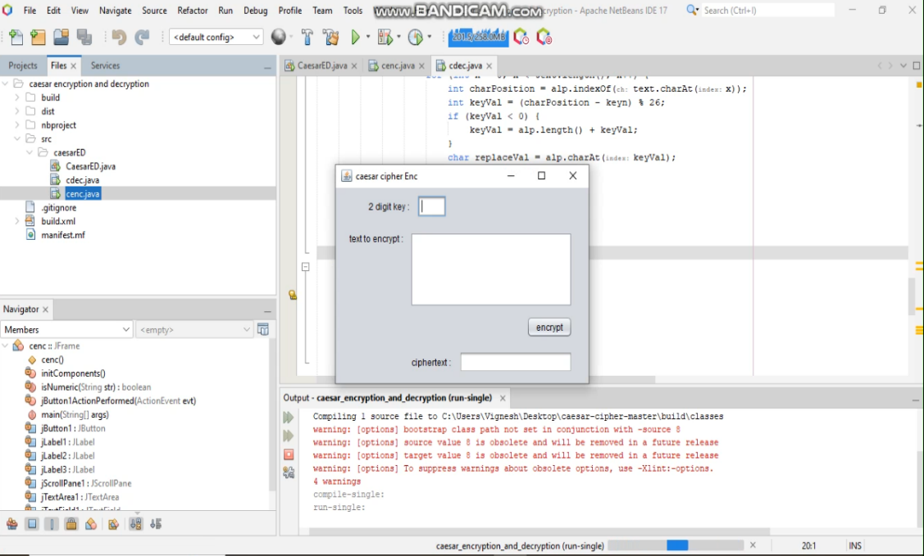

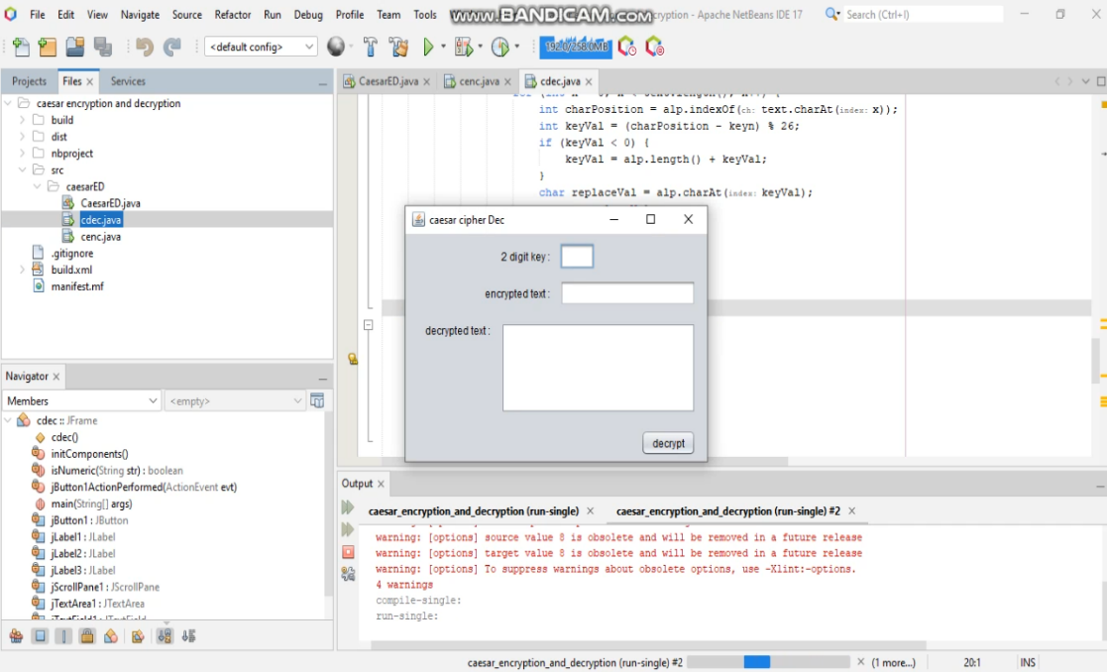

Remember that this is a basic implementation for educational purposes. In real-world applications, more advanced encryption algorithms with larger key spaces are recommended for security.

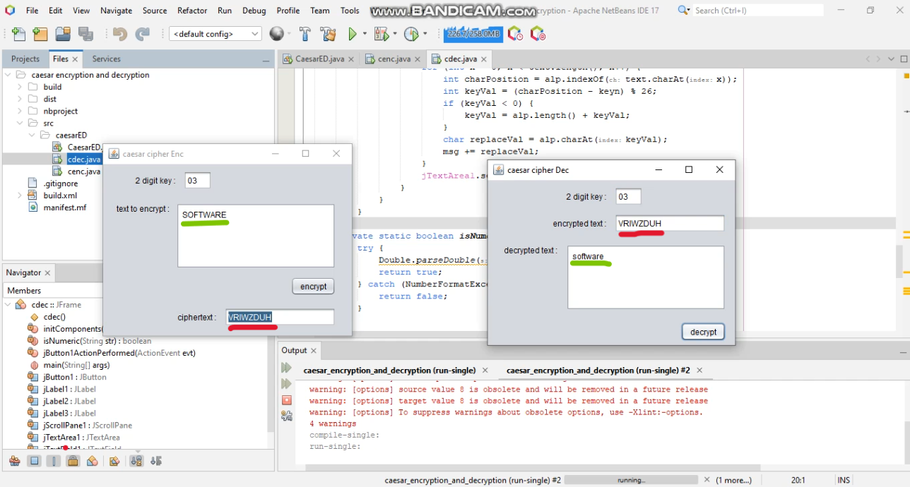**CONCLUSION**

The Caesar Cipher project has provided a comprehensive exploration of this foundational encryption method within the context of modern cybersecurity. Through the implementation of software applications, educational tools, and thorough security analyses, the project aimed to showcase the strengths, weaknesses, and educational value of the Caesar Cipher.

The simplicity of the Caesar Cipher, while historically significant, has been underscored by its vulnerability to brute-force attacks due to its limited key space. The project successfully demonstrated the encryption and decryption processes, shedding light on the algorithm's straightforward architecture. Moreover, the security analysis simulated potential threats, emphasizing the importance of combining the Caesar Cipher with additional security measures in practical applications.

In conclusion, this project has contributed to a nuanced understanding of the Caesar Cipher's role, limitations, and educational significance in the evolving landscape of information security and cryptography. While not suitable for high-security applications, the Caesar Cipher remains a valuable tool for educational purposes and historical exploration.

THANK YOU!